Activiity 1 - Family
This activity will help you to learn the vocabulary about some of your family members.
Timings: 20 mins
- Discuss the meaning of the words in the box.

Grandmother | Mother | Aunt | Brother
Grandfather | Father | Uncle | Sister

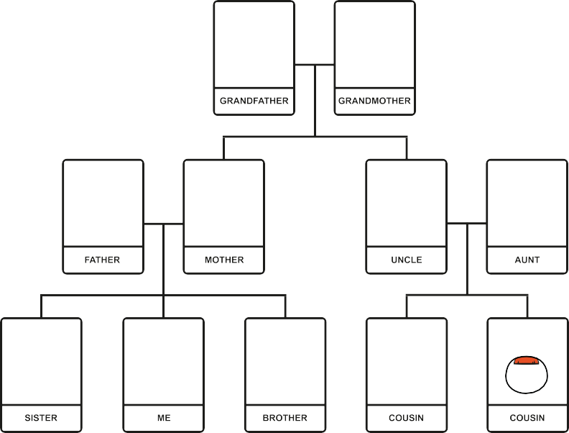
- Look at the family tree example.
- Now, using the space below, draw your own family tree.

Activity – Fill in the gaps
Timings: 10 mins
- Now complete the sentences.

My name is . . . . . . . . . . . . . . . . . . . . . . . . . . . . . I have . . . . . . . . . . . . . . . . . . . . . . . .. . . . brother(s) and . . . . . . . . . . . . . . . . . . . . . . . . . . . .

sister(s). I live with my . . . . . . . . . . . . . . . . . . . . . . . . . . . . and . . . . . . . . . . . . . . . . . . . .. . . . . . . . . My . . . . . . . . . . . . . . . . . . . . . . . . . . . . and

. . . . . . . . . . . . . . . . . . . . . . . . . . . . live in . . . . . . . . . . . . . . . . . . . . . . . . . . . . .

Extension Activity
Timings: 10 mins
- Do you know any other words for family members?
- Try to match the words to the meanings.

Sister’s son | Niece
Sister’s daughter | Cousins
Uncle’s children | Sister in law
Sister’s husband | Nephew
Brother’s wife | Husband or wife
The person you are married to | Brother in law

Extension Activity Activity Outline Timings: 10 mins
There are some really useful ESOL YouTube clips that could be adapted or used to practise family conversations.
Watch the following clip and practise asking the questions with your family.
www.youtube.com/watch?v=OogniMZFyw4.

Activity 2 - Introducing Yourself
This activity will help you learn useful phrases for introducing yourself.

Meeting new people is a great way to feel part of the community.

Activity

Hi, my name is Maria and
I come from Brazil. I am 27 years old.
I live in Camden in London with my husband Fabio and two children Felipe and Juan. I like to help out at my childrens’ school. At the weekend
we like to go walking.
Timings: 15 mins Meet Maria

- Now read the questions below and write the answers in the blank space. Q: What is your name?
A: My name is A: . . . . . . . . . . . . . . . . . . . . . . . . . .

Q: Where do you come from?
A: . . . . . . . . . . . . . . . . . . . . . . . . . . . . . . .

Q: Where do you live?
A: . . . . . . . . . . . . . . . . . . . . . . . . . . . . . . .

Q: Do you have any children?
A: . . . . . . . . . . . . . . . . . . . . . . . . . . . . . . .
Q: Do you have a job?
A: . . . . . . . . . . . . . . . . . . . . . . . . . . . . . . .
Q: What do you like to do at the weekend?
A: . . . . . . . . . . . . . . . . . . . . . . . . . . . . . . .

Activity 3 - Meeting New People
Timings: 20 mins
This activity will help you to practise asking and responding to questions in new social situations.

your | How | ? | ? | Where
? | Where | are | you | Nice
How | many | children | you | to
you | you | do | What’s | from
name | do | have | ? | meet
old | ? | you | live | are
! | married | job | you | ?
Are | your | ? |  | What’s

- How many sentences can you make from the words in the grid? Remember that all sentences begin with a capital letter.
- Remember that questions end with a question mark?
- Write your sentences in the table below.
- The first one is done for you.

1 . How are you?
2 .
3 .
4 .
5 .
6 .
7 .
8 .

Activity – Group Discussion
Timings: 10 mins
You may have noticed this symbol - ! - in the grid. This is called an exclamation mark. We use it to express strong feelings. E.g. excitement, shock, warning.
- Can you think of a sentence that has an exclamation mark in it? E .g . “Hello, it’s so good to see you!” - shows excitement.
“Don’t walk on the road it’s dangerous!” - shows fear/warning.
Sometimes you may see this symbol on road signs to warn you that it is dangerous ahead.

Extension Activity
Timings: 10 mins
We can often tell what something means by looking at signs and symbols even when we don’t understand the words .
- Have a look around you on the way home and see how many symbols or signs you know.

Activity 4 - Festivals and Celebrations across the UK
Timings: 15 mins
This activity will help you to get to know some of the most important festivals that take place across the United Kingdom every year.
Listed below are the most popular British festivals and celebrations.
- Look at the pictures and share any experiences you have had of these festivals.

Christmas
a Christian festival where people offer gifts
25th December

New Year
a public holiday
1st January

Easter
a Christian festival
Spring time March / April

Guy Fawkes
a bonfire night
5th November

Valentine’s Day
a day to celebrate love
14th February

Mother’s Day
a day to celebrate mothers
March

Father’s Day
a day to celebrate fathers
June

Birthday celebrate the day you were born
Any time

April Fool’s day
a day when people play tricks on each other
1st April

Shrove Tuesday a day for making pancakes
February / March

Chinese New Year celebrated at the turn of the Chinese calendar
January / February

Harvest Festival
a celebration of the food grown on the land
September

Eid al-Fitr
also called Feast of Breaking the Fast. Marks the end of Ramadan, the Islamic holy month of fasting
Winter time - July

Diwali - also called the “festival of lights” signifies the victory of light over darkness, knowledge over ignorance, good over evil, and hope over despair
October / November

- The UK is very multi-cultural and there are many more festivals.
- You may wish to share your favourite cultural festival with the group too!

Activity
Timings: 15 mins
- Can you match the festivals in the table to the season of the year?

Winter | Spring
Summer | Autumn

Extension Activity - Discussion
Timings: 10 mins
- Discuss your favourite season and festival.
- If you have children at school, what festivals do they celebrate at school?
- Do you visit school assemblies to share the celebrations

Find out if your local community centre holds celebration events – why not go along?

