Keeping Up

Activity 1 - Excuses, excuses, excuses
This activity will help to increase your vocabulary and understand the language used in transport announcements.
Timings: 15 mins
Trains can be late for a number of reasons. We call this a delay.
- Look at the statements about train delays and reasons why this has happened.
- Take it in turns to read through the excuses and make sure you understand the vocabulary – use the pictures to help you.
Announcements made today!
1 .
The 11:30am from Paddington is delayed due to a signal fault
2 .
The 9.45am to Liverpool Street is delayed due to heavy rain
3 .
The 6.15pm from Charing Cross is delayed due to snow
4 .
The 7.02pm to Victoria is delayed due to leaves on the line
5 .
The 8.36am to Euston is delayed due to ice on the rails
6 .
The 10.18pm from Marylebone is delayed due to a
broken window
7 .
The 6.00pm hours Eurostar to St Pancras is delayed due to a fire
8 .
The 3.55pm from King’s Cross is delayed due to a
cow on the line

- Now see if you can complete the table below writing the information for each delay in the correct box.
- Look carefully as they are not in the same order.
- Make sure your answers are correct or you may miss your train.

 | Train Time | Station | Reason for delay
1 | 11.30am | Paddington | Signal fault
2 |  | Victoria
3 | 10.18pm
4 |  | Eurostar
5 |  |  | Ice on the rails
6 | 3.55pm
7 |  | Liverpool Street
8 | 6.15pm

Extension Activity - Group and pair work
Timings: 20 mins
Club Leader distributes Tube Map or local train map.
- Have a look at the map. Where is the nearest train station to your home?
- Have you used the train before?
- Can you tell me how to get from your home to Oxford Street by Tube?
- Practise finding different stations on the map from your nearest station.

Divide into pairs with one map between each pair.
Person A is lost and needs help .
Person B reads the map and gives directions.
Person A: Choose two stops on the map and ask for directions from one to the other.

A: “Excuse me can you tell me how to get from . . . . . . . . . . . . . . . . . . . . . . . . . . . . to . . . . . . . . . . . . . . . . . . . . . . . . . . . . ?

B: Yes, you take the . . . . . . . . . . . . . . . . . . . . . . . . . . . . and change at . . . . . . . . . . . . . . . . . . . . . . . . . . . . then take

the . . . . . . . . . . . . . . . . . . . . . . . . . . . . to . . . . . . . . . . . . . . . . . . . . . . . . . . . . and you will arrive.

- Do this as many times as you like. You will soon know how to travel with confidence.

Activity 2 - Keeping Up: Think of a . . .
This activity will help you increase your vocabulary and knowledge of every day nouns.
Timings: 15 mins
Aa
- There are 2 sets of cards one contains letters of the alphabet.
- The other has different questions on each.

Alphabet flashcards
Bb
Cc
Dd
Ee
Ff

Gg
Hh
Ii
Jj
Kk

Ll
Mm
Nn
Oo
Pp

Qq
Rr
Ss
Tt
Uu

Vv
Ww
Xx
Yy
Zz

Question cards
- Work in pairs - divide the question cards between you.
- Put the alphabet cards on the table face down. Turn over a letter of the alphabet and choose a Q card question to ask your partner.

Think of a river that begins with

Think of a car that begins with
- Now swap over.
- Choose another letter – you can play this game as many times as you like changing question and letter each time.

Think of a colour that begins with

Think of a bird that begins with

Think of a shape that begins with

Think of a country that begins with

Think of a flower that begins with

Think of a food that begins with

Think of a sport that begins with

Think of a vegetable that begins with
Think of a Capital City that begins with

Think of a fruit that begins with

Activity 3 - Weather forecast
This activity will help you to increase your vocabulary about the weather and understand the meaning of small talk.
Timings: 10 mins
In the UK, people talk a lot about the weather. This is known as small talk. Here are some weather words.

Rain | Sunshine | Thunder Storms
Cloudy | Showers | Fog
Snow | Wind | Ice
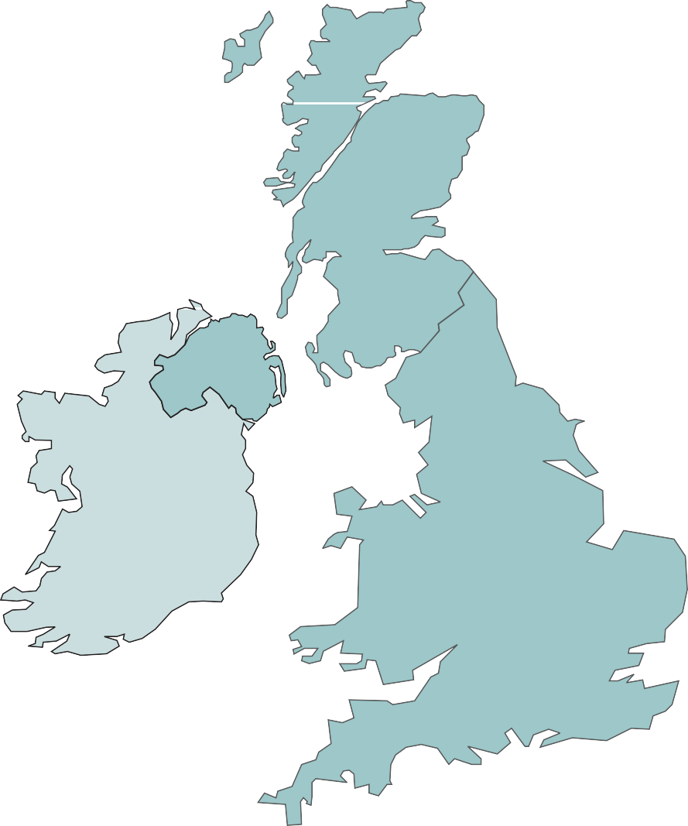

- Look at the map of the United Kingdom – there are some weather symbols on this. What do you think the symbols mean?

Activity – Small talk
Timings: 15 mins
Below are some phrases that people say when talking about the weather.
- Can you work out what sort of weather it is?

A: It’s a lovely day today isn’t it?

B: Yes, I love the . . . . . . . . . . . . . . . . . . . . . . . . . . . .

A: It’s a terrible day isn’t it?

B: Yes, I wish it would stop . . . . . . . . . . . . . . . . . . . . . . . . . . . .

A: It is so . . . . . . . . . . . . . . . . . . . . . . . . . . . . today my hat blew away.

B: Oh dear, the . . . . . . . . . . . . . . . . . . . . . . . . . . . . is hurting my ears.

A: Did you hear the . . . . . . . . . . . . . . . . . . . . . . . . . . . . last night?

B: Yes and I saw . . . . . . . . . . . . . . . . . . . . . . . . . . . . flashes too!

raining | windy | thunder
sunshine | wind | lightning

- Work in pairs and practise the small talk using the sentences above to help you.

Extension Activity - Group discussion
Timings: 10 mins
- Why do you think people talk so much about the weather in this country?
- What was the weather like when you left home to come here?
- What is the weather like now?
- Do you think the weather can affect how people feel?

Activity 4 - Practise: Could, Would

Activity Outline
This activity will help you to use positive vocabulary when making a request or complaint.
Timings: 20 mins

Could you please? | Would you mind?

Whole group practice
Club Leader points to one of the group and says “(name of learner), could you please pass me that book?
- Learner A: Yes, of course.
- Learner A: Points to another group learner and asks the same question.
- Learner B: Responds .
Take turns until everyone has responded.
Club Leader repeats the game using the phrase: Would you mind?
Would you mind standing up and closing the window?
- Student A: No, of course not.

Activity – Complete the phrase
Timings: 15 mins
You can use the phrases: Would you mind? Or could you please? When making a polite complaint too .
E.g. would you mind not talking so loudly? Could you please be quiet?

Work in pairs.
- Look at the pictures and complete the phrases. How would you respond?
- Practise the conversation with your partner.

Could you/would you…

Could . . . . . . . . . . . . . . tell me the time?

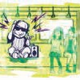
Could . . . . . . . . . . turn your music down

Would you . . . . . . . . . . . . giving me your seat?

Would . . . . .. . . . .. . . . passing me that can of paint?

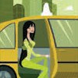
Could . . . . . . . . . . . . take me to the station

Could . . . . . . .. . . . . . . . bring the bill?

Would . . . . . . . . . .. . . . . . . . . please read the first page of your book?

Extension Activity - Group Discussion
Timings: 10 mins
- Have you ever had to give up your seat on a bus or train? Did you know that there are special seats for people with additional needs e.g. disabled, older people?
- Has anyone ever given up a seat for you on a bus/train?
- If yes, how did that make you feel?
- Have you ever had to make a complaint to a neighbour?
- Has anyone ever complained to you about someone else?

