[](http://www.inmagine.com/spl007/spl007738-photo)





[](http://www.google.co.uk/url?url=http://www.parkview.com/en/wellness/Flu%20Facts&rct=j&frm=1&q=&esrc=s&sa=U&ei=5_wrVLixA-KhyAOQ-4LIAQ&ved=0CCIQ9QEwBg&usg=AFQjCNHm3e3wfIsJDqtoAFtNpnLgMCpucA)

[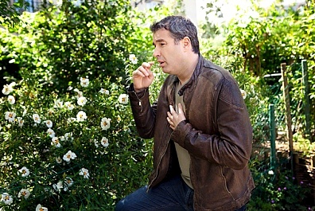](http://www.inmagine.com/bsip-037/ptg03521667-photo)[](http://www.inmagine.com/spl008/spl008348-photo)

[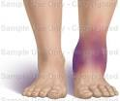](http://www.google.co.uk/url?url=http://www.doereport.com/generateexhibit.php?ID=4139&ExhibitKeywordsRaw=&TL=&A=&rct=j&frm=1&q=&esrc=s&sa=U&ei=3_4rVLB0pdPKA-fXgtAD&ved=0CDwQ9QEwEw&usg=AFQjCNHOJmrlnnkJi4UGRNFSaaToZT8H5g)

[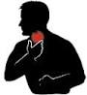](http://www.google.co.uk/url?url=http://www.kroegerhealer.com/what-causes-chronic-sore-throat-chronic-burning-throat-chronic-clearing-throat.htm&rct=j&frm=1&q=&esrc=s&sa=U&ei=__0rVLG4C6TiywOBwoDwCw&ved=0CBgQ9QEwATgU&usg=AFQjCNFdcI6EpkLbWpzL5J9-QCO0-sM-gg)[](http://www.google.co.uk/url?url=http://www.chathampublichealth.com/general/remember-to-get-your-flu-vaccine/&rct=j&frm=1&q=&esrc=s&sa=U&ei=vv0rVN7HCeKAywPUsoGYCQ&ved=0CBYQ9QEwAA&usg=AFQjCNHeG325QPE6YlxFUYBED1RACZZkJw)

[](http://www.google.co.uk/url?url=http://www.englishexercises.org/makeagame/viewgame.asp?id=7131&rct=j&frm=1&q=&esrc=s&sa=U&ei=b_0rVPDAHMmrygPqkIC4Bw&ved=0CCYQ9QEwCDgU&usg=AFQjCNHeHbBwHr--VlZ7277yA6ZDZdD2tw)[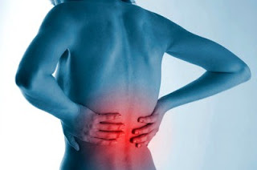](http://4.bp.blogspot.com/_u2vyDUW07KY/TID0PNjNkII/AAAAAAAAAAw/qRf-XxqyQMw/s1600/back+ache.jpg)

[](http://www.inmagine.com/ins063/ins063379-photo)