Keeping Safe

Activity 1 - Keeping Safe
This activity will help you learn home safety vocabulary and practise prepositions.
Timings: 15 mins
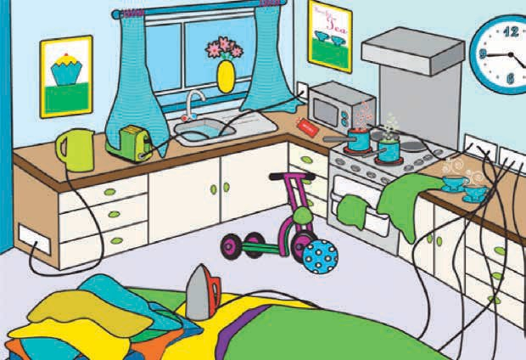
Image courtesy of Staffordshire Fire and Rescue Service

- Look at the home hazard picture.
- Write down 5 things which are dangerous in this picture .

1
2
3
4
5

- Share your answers with the group.

Activity 2 – What would happen if?
Timings: 15 mins
- Discuss what would happen if:
  - The iron fell over?
  - A child pulled the tea towel near the cooker?
  - Someone switched the toaster on?

Extension Activity - Group Discussion
Timings: 15-20 minutes
- Has anyone ever had an accident in their home?
- Share any experiences with the group.
- Would you know how to get help if a fire broke out or an accident happened in your home?
- Club Leader distributes fire prevention leaflets/information and group discuss the content.
- Is it important to have a fire extinguisher or fire blanket in your kitchen?
- How many of you have smoke detectors in your home?

Activity 3 - Home safety
Timings: 15 mins
This activity will help you with Home Safety vocabulary and following instructions.
- Here are some instructions to help you keep safe from fire in the home
- Read through the instructions and discuss the vocabulary.
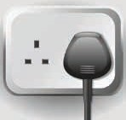
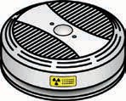
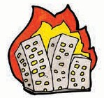

Plugs

Smoke alarm

Burning building

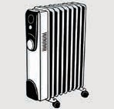
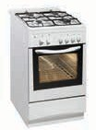
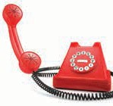

Heaters

Cooker

Dial 999

Fire Prevention Advice
- At night pull out all plugs except the fridge/freezer.
- Make sure the cooker is turned off.
- Turn off all heaters.
- Make sure all candles or cigarettes have been put out.
- Check that you have put your door keys in a safe place. 6 . Close all doors .
- Make sure nothing is blocking the exits.
- Make sure your smoke alarm is working.
- If a fire breaks out – get everyone out and dial 999.
- Never try to go back into a burning building.

Activity 4 – True or false?
Timings: 10 mins
Read through these statements and decide if they are True or False .

- You should always leave a light on when you go to bed. True False

- Smoke alarms should be placed above a window? True False

- If a fire breaks out you should stay in your room and dial 999. True False

- It is a good idea to leave your bike in the hallway in front of the door. True False

- You should never enter a burning house. True False

- You should make sure all candles and cigarettes have been put out before you go to bed. True False

Extension Activity - Group Discussion
- Do your children and other family members know what to do in a fire?
- Do you have a plan in case of fire?
- Does everyone in your family follow the Fire Safety Advice?
- Has anyone ever had to call the emergency services? If the group would like to practise, this could be included in the next session as a role-play activity, i.e. making an emergency telephone call .

Activity 5 - Keeping Safe
This activity will help you understand the importance of road safety and key words linked to this.
Timings: 10 - 15 mins
Write the Road Safety words under the picture

1 . Pelican crossing | 4. Traffic lights
2. School crossing patrol (lollipop person) | 5. Seat belts
3. Bicycle helmet | 6. Zebra Crossing

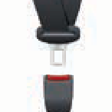
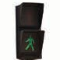
. . . . . . . . . . . . . . . . . . . . . . . . . . . . . . . . . . . . . . . . . . . . . . . .

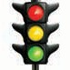
. . . . . . . . . . . . . . . . . . . . . . . . . . . . . . . . . . . . . . . . . . . . . . . .

. . . . . . . . . . . . . . . . . . . . . . . . . . . . . . . . . . . . . . . . . . . . . . . .

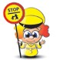
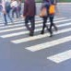
. . . . . . . . . . . . . . . . . . . . . . . . . . . . . . . . . . . . . . . . . . . . . . . .

. . . . . . . . . . . . . . . . . . . . . . . . . . . . . . . . . . . . . . . . . . . . . . . .

. . . . . . . . . . . . . . . . . . . . . . . . . . . . . . . . . . . . . . . . . . . . . . . .

. . . . . . . . . . . . . . . . . . . . . . . . . . . . . . . . . . . . . . . . . . . . . . . .

. . . . . . . . . . . . . . . . . . . . . . . . . . . . . . . . . . . . . . . . . . . . . . . .

. . . . . . . . . . . . . . . . . . . . . . . . . . . . . . . . . . . . . . . . . . . . . . . .

. . . . . . . . . . . . . . . . . . . . . . . . . . . . . . . . . . . . . . . . . . . . . . . .

. . . . . . . . . . . . . . . . . . . . . . . . . . . . . . . . . . . . . . . . . . . . . . . .

. . . . . . . . . . . . . . . . . . . . . . . . . . . . . . . . . . . . . . . . . . . . . . . .
Road Safety facts - the school run

Many schools have a zebra crossing to keep children safe going to school. There are more cars on the road when children are going to school than at any other time of the day.

Teach your children to Stop, Look, Listen and Think before they cross. Fill in the blank spaces using the words from the box above.

Mia goes to school with her mum. She always uses the . . . . . . . . . . . . . . . . . . . . . . . . . . . . . The road is very busy and there is also a . . . . . . . . . . . . . . . . . . . . . . . . . . . . . . . . . . . . . . . . . . . . . . . . . . . . . . . . . . . . . . . . . . . . . . . . . . . . . . . . . . . . .
Sometimes Mia goes on her bike and she wears a . . . . . . . . . . . . . . . . . . . . . . . . . . .. . . . . . . . . . . . . . . . . . . . . . . . . . . . . . After school Mia and her mum go to the shops. They have to cross at a . . . . . . . . . . . . . . . . . . . . . . . . . . . .
. . . . . . . . . . . . . . . . . . . . . . . . . . . . and a set of . . . . . . . . . . . . . . . . . . . . . . . . . . . . . . . . . . . . . . . . . . . . . . . . . . . . . . . . . When Mia and her mum take the car they always wear . . . . . . . . . . . . . . . . . . . . . . . . . . . . . . . . . . . . . . . . . . . . . . . . . . . . . . . . .

Extension Activity - Group Discussion
Think about road crossings in your local area.
- Do you always use the crossings available?
- Do you teach your children about Road Safety?
- Do you think the roads in your area are safe or could they be improved?

