**La hora**

* Una hora son 60 minutos
* Media hora son 30 minutos
* Un cuarto de hora son 15 minutos
* Un minuto son 60 segundos

**What time is it?**

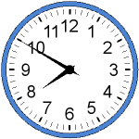 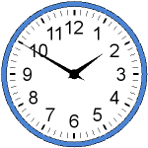 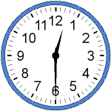

Son las 8 menos 10 ______________________ ________________________



  