Making a journey on the Tube
- Find your route. Every Tube station has a big map that you can use to look at your journey. You can also download free apps on your phone that give you a copy of the Tube map. This is good as it means you have a copy of the map everywhere you go.

- Check your Oyster Card balance. You can pay for your journey using your Oyster card. Before you take the Tube, it is good to check your balance using the machines in the station. If you need to add money – you can do this using the machine. Remember: if you need help, ask one of the station staff and they can show you how to use the machine

- Tap your Oyster card in at the barriers. To start your journey, tap your oyster card in at the barrier and walk through.

- Look for the signs directing you to the Tube Line you want to take. When you are through the barriers, follow the signs for the line you want to take (e.g Circle Line, Metropolitan)

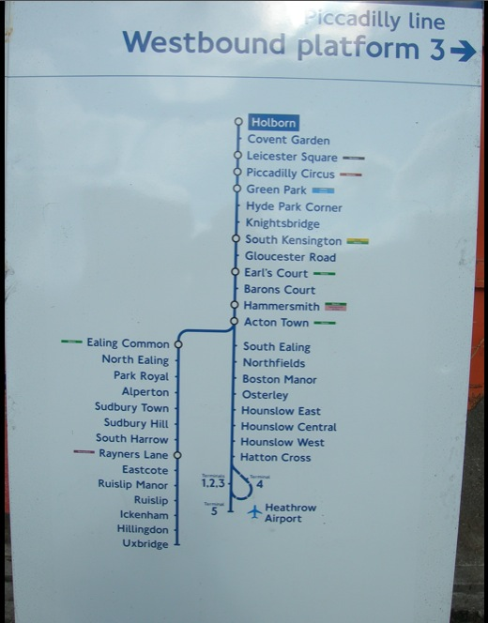
- Work out which platform to take. Tube trains always run in two directions. You need to look at the different signs to work out which direction you want to go. To do this, remember the station you want to go to and look for the name of the station on the sign. The arrow will then tell you which platform to go to (see photos below)
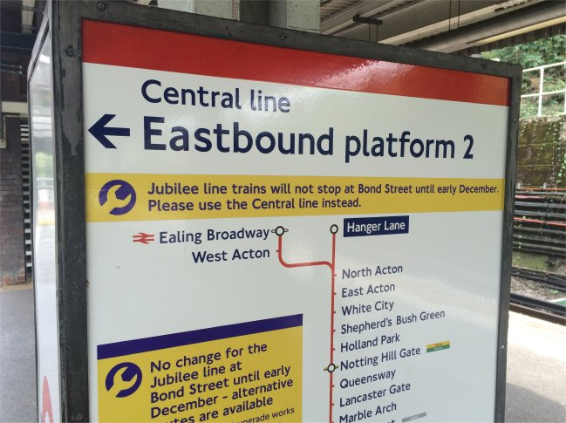

- Wait for your Train. Wait on the platform until your tube train arrives. When you are waiting, look at the display board to see how long it is until your train arrives.

The board will say how many minutes until the next train.

- When your train arrives check the front of the train to make sure it is going to stop at the station you want (Sometimes tube trains don’t go to the end of the tube line – so you need to make sure it is going as a far as your tube stop). Remember to stand back from the edge when the train arrives!
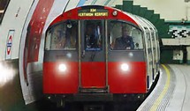

- On the train….Now you are on the train, sit back and enjoy the ride! Remember to keep looking for your stop. There is usually a screen on the train that tells you the next stop. Sometimes a lady’s voice plays out on a speaker to tell you the next stop too.

- Getting off your train. When you have reached your stop, get off the train. If you are changing to another line, look for signs to direct you to your new tube line. If this is the end of your journey, follow the signs to the exit.

- Remember to tap out using your Oyster card at the end of your journey. Otherwise, you may get charged the maximum fare.

Remember – Don’t worry if you get lost – all the Tube staff are paid to help you find your route – so always ask if you need any help

