**Time**

One hour is 60 minutes – an hour – hours, a minute – minutes

A half hour is 30 minutes

A quarter is 15 minutes

A minute is 60 seconds – a second – seconds

**What time is it?**

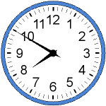 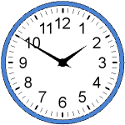 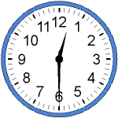

It is ten to eight ______________________ ________________________



  