What time is it?
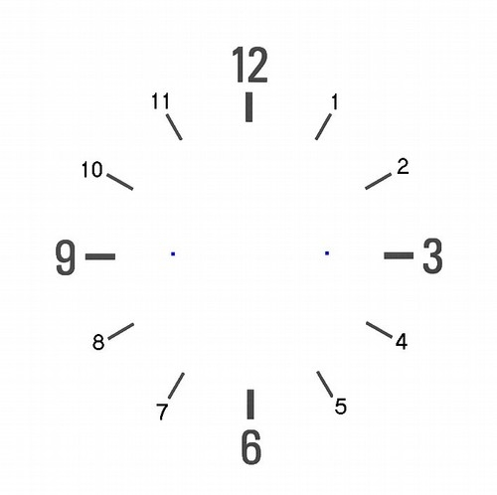
Five to twelve
A quarter to ten Twenty past four
Five to seven Twentyfive to three
Ten to two Twentyfive past six
Five past eight Half past one
Twenty to twelve Five past two

